Year 10 Photography GCSE coursework unit

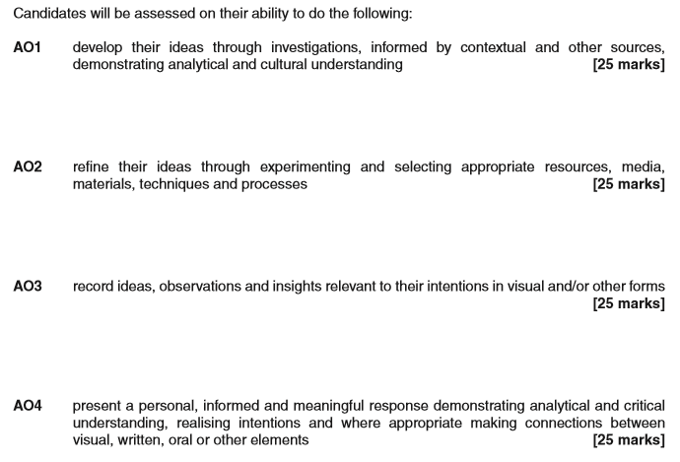
You are required to select a starting point and create your own personal response to your chosen selection.
Starting points
1 Family tree
Ancestry, origin, genealogy, descendants, roots, family, relatives, parents, line, nationality, history…
Possible photographers to research include: Sally Mann, Shelby Lee Adams, Richard Billingham

2 Patterns in nature
Seasons, cycles, tides, footprints, pathways, bark, feathers, sand, skin, shells, fur, flowers, fruit, webs, scales…
Possible photographers to research include: Karl Blossfeldt, Edward Weston, Galen Rowell

3 Broken and/or damaged
Decay, rot, rust, shattered, scrap, derelict, cracked, weathered, aged, forgotten, left, peeling, crumbling…
Possible photographers to research include: Keith Arnatt (rubbish tip), William Christenberry (southern buildings), Matthew Merrett,

4 Time
Seasons, cycles, aging, decaying, growing, change, movement, birth, death, relationships, fashion…
Possible photographers to research include: Anee Geddes, Paul Caponigro (white deer), Nir Arieli

5 Jumble/collections
Old, new, discarded, disused, priceless, vintage, fashion, useless, natural, man-made, food, memories…
Possible photographers to research include: Sophie Calle, Jim Golden, Emily Blincoe

