Your School Name Primary School
Or organisation And
Address

Headteacher/contact name :
your school logo/organisation logo/artsmark logo etc

'From my back door'
Home Learning 2020 Art Project: ‘From My Back Door - Art From Nature’
There are many artists who are drawn to nature as a source of inspiration. I would like you to use this inspiration to make your very own work of art work over the coming weeks.
The rules for the project are simple. Using nature as your stimulus make a work of art that you can bring to school when we all return. Your work can be in any medium, it can be flat on piece of paper or on a canvas or 3d. It must be no larger than A4 size. It could be really tiny! It can be a drawing, painting, a collage, printmaking, an artist book or a piece of textile art. It could be a tiny sculptural piece, you could use something from nature and add to it. See the attached pictures, websites and artists as a starting point, don’t forget Pintrest has tons of great ideas too - just input children’s nature art.
When you finish, please label your work with your name and age and also write a short artist statement (example attached), of no more than 300 words about what inspired you to make it. Think about the artists you looked at first, the piece of nature that was your starting point, why you made it etc. Lastly make up a great title for your work.
Taking part in this Art Learning Project is optional but all children who do take part will receive a certificate when they return their work to school and we will exhibit all works in a mini art show. There will be two categories infant and junior, Prizes will be awarded to the most well thought out three in in each group.
There is a wealth of inspiration from nature just outside your back door. Your creativity is waiting to be unleashed! You just need to look! Happy making and see you all soon!
Your name
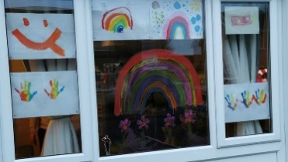
Art Co-ordinator and Class Teacher
PS If you can, please don’t forget to make a picture of a rainbow for your window at home! https://www.bbc.co.uk/newsround/51953553
PPS Later this week ‘firstsite’ will be releasing as artist activity pack which is free. The pack, Art is where the home is’ aims to provide ideas about how to get creative at home. Anyone can have a go – there are no specialist materials required. See the website for info https://www.bbc.co.uk/newsround/51953553
Ideas pages:
make an art book….
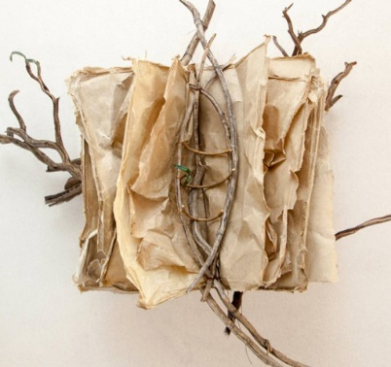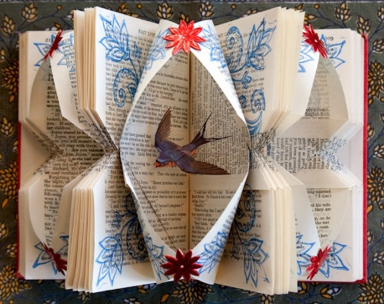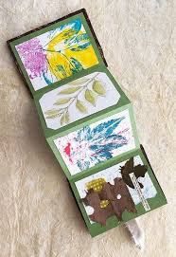
Do some close observational or botanical drawings or paintings, draw a tree
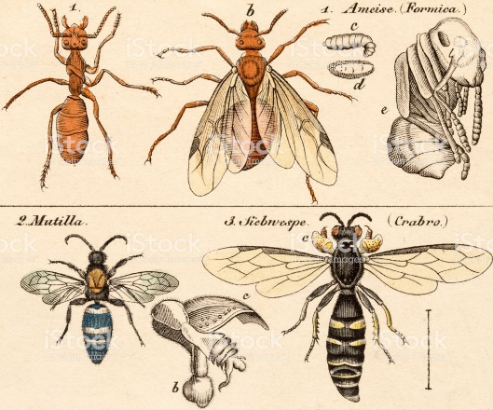
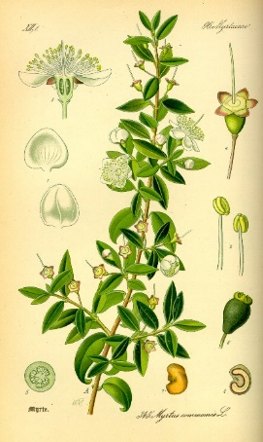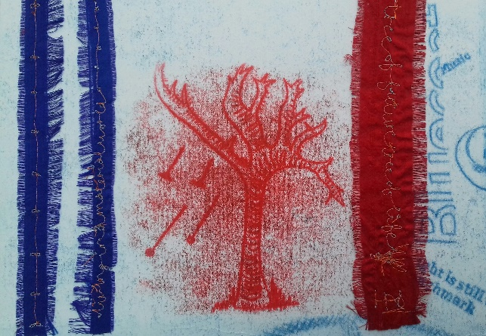
Paint a stone, varnish it with PVA… Print from leaves….
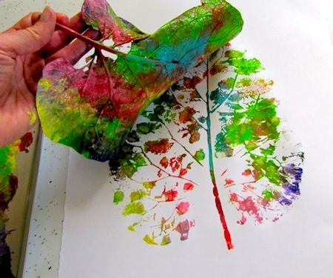
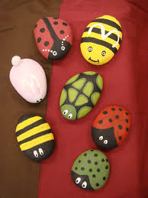
Collage!
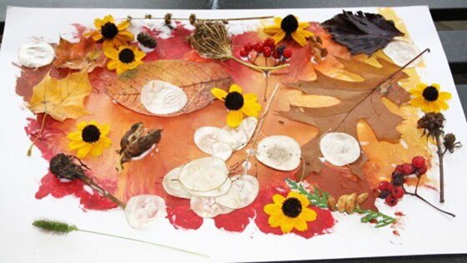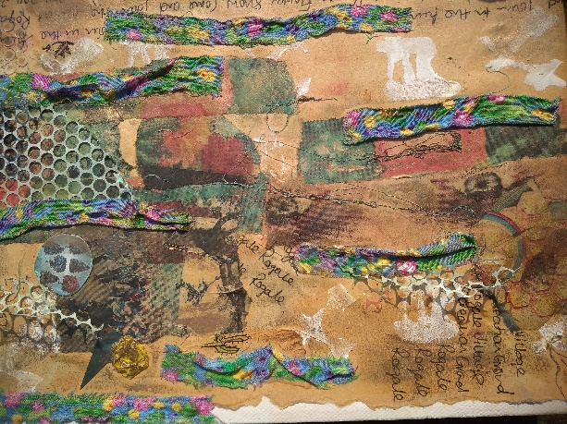
Make some art from nature and photograph it, stitch a leaf, weave some grass…..
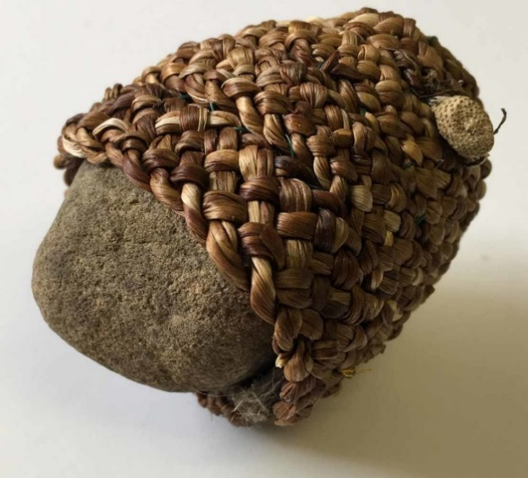
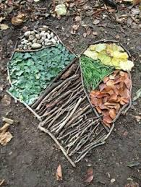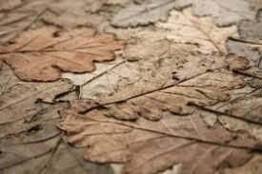
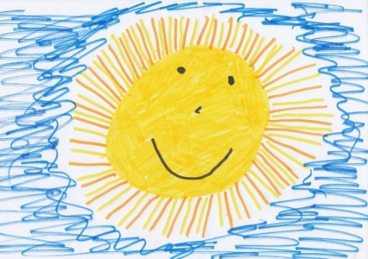
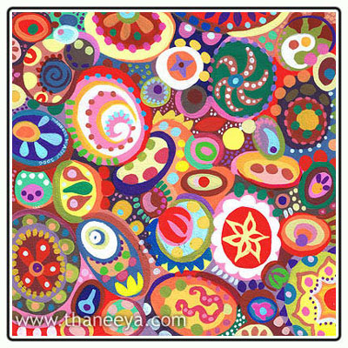
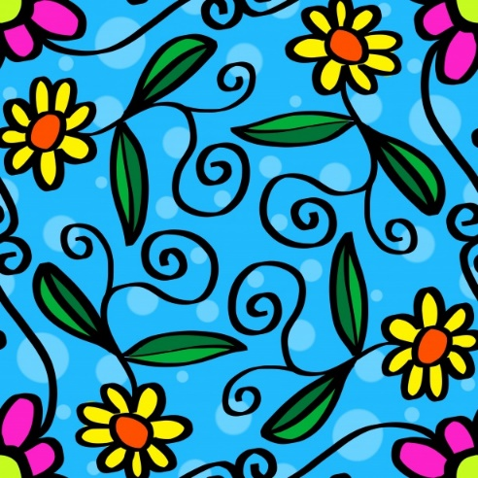
Draw what you see! Abstract the shapes you see and make them in to colourful patterns.

Really famous works of art inspired by nature…
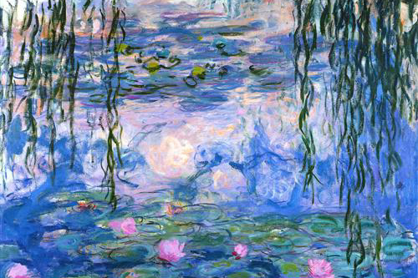
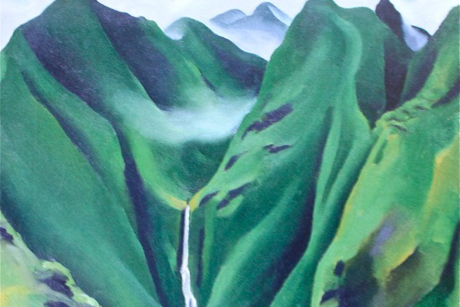

Waterfall, No 1 Iao Valley Maui Georgia O’Keefe Water Lilies Claude Monet
oil on canvas 1939 oil on canvas 1917-19

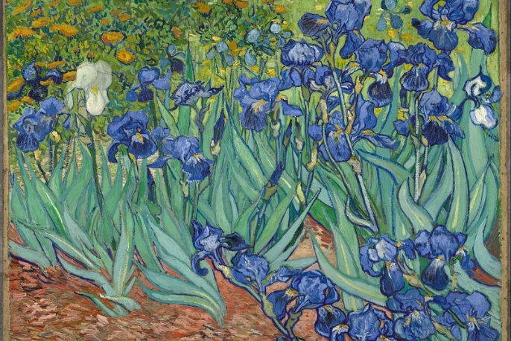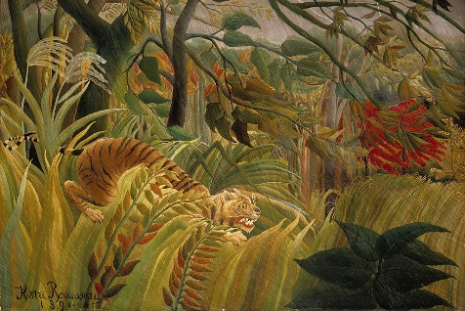
‘Irises’ Vincent Van Gogh ‘Surprised’ Henri Rousseau
oil on canvas 1889 oil on canvas 1891

And finally, a few more ideas:

Take a piece of paper and pencil and draw what you see. Can you draw flowers and other natural forms from your garden? Make view finder. Draw what you see through it. Make it abstract. Make something sculptural. Country Diary of an Edwardian Lady has some lovely botanical drawings in it. Have you got a copy of it in the house? What other art books have you got lying around to inspire you? Look in newspapers and magazines for more ideas. Use images of nature to make a collage. Make little book out of scrap paper or use an old notebook. Record your processes. Record your ideas. Call it your ideas book. You might have lots of ideas you want to try out first then choose your favourite one to develop. Remember you have plenty of time to work on your finished piece, don’t rush. If you have access to the internet look at some artist websites for inspiration. Here are two to start you off: http://www.arttextilesmadeinbritain.co.uk/the-artists.html https://www.tate.org.uk/tate-etc/issue-1-summer-2004/cultivated-minds-art-garden. A few artists to google: Andy Goldsworthy, Stephanie Redfern, Nils Udo, Richard Schilling, Fan Kuan.
Example of an artist statement to explain your work:
title of my piece | ‘that tree outside’
media used | paint, pencil, collage
your name | Jo Bloog
your age | Age 10
statement - why you chose what you chose, what you did, artists that inspired you. | I looked outside and the first thing I saw was the huge tree at the bottom of my garden. I decided to draw the tree and then printed from its’ leaves. This took me quite a long time. I then decided to draw the animals and birds that I could see on the tree. I used the shapes and drawings I made for my final piece. Artists that inspired me are Stephanie Redfern and Vincent Van Gogh.
Don’t forget the best inspiration is what you see outside. Step outside your back door or look out of your window. See things with fresh eyes. Really look. Whatever you see and record will be special and unique to you!
Remember your ideas will be loads better than mine! Good luck, enjoy, get creative and get making!

