Autumn Term Assessment ’MECHANIMALS’
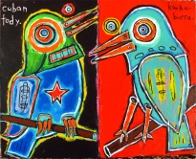 |  | Artists, artworks and meaning  AO1 ‘Develop’  Research/opinion |  | WWW:  EBI:  INT:
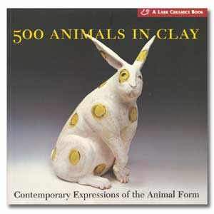 |  | AO2‘Experiment’  Artist copy/Artist response 2D/3D  Oil pastel, clay, colour pencil, paint, print |  | WWW:  EBI  INT:
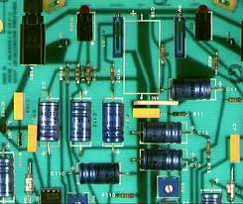 |  | AO3 ‘Record’  Explain ideas  Thoughts, opinions |  | WWW:  EBI:  INT:
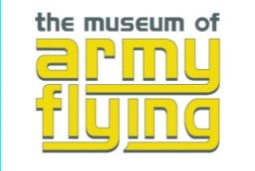 |  | AO3 ‘Record’  Photography  Drawing |  | WWW:  EBI:  INT:
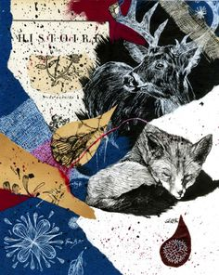 |  | AO4 ‘Present’  Sketchbook  presentation and annotation  FINAL OUTCOME that links to an artist |  | WWW:  EBI:  INT:
Spring Term
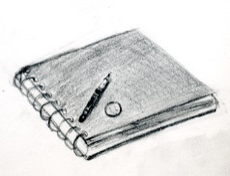 |  | Design Idea 1 | WWW:  EBI:  INT:
 |  | Design Idea 2 | WWW:  EBI:  INT:
 |  | Design Idea 3 | WWW:  EBI:  INT:
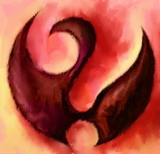 | Final Piece |  | WWW:  EBI:  INT:

